**Class Exercise: Search for text pattern in files using “grep/egrep”, after locating the set of files.**

Execute the following tasks, capture and paste your results onto this document accordingly.

1. Write the command to locate all the files at /usr that has the file extension of .txt?

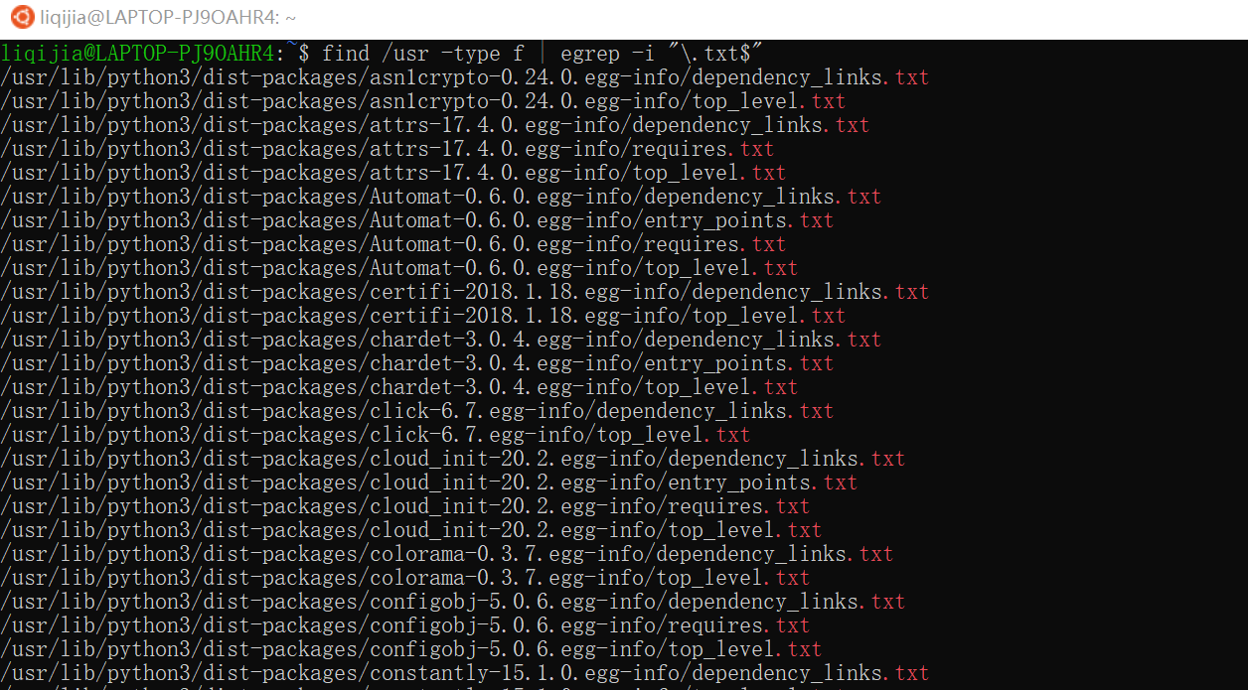

1. Execute this command, and read its output: man egrep



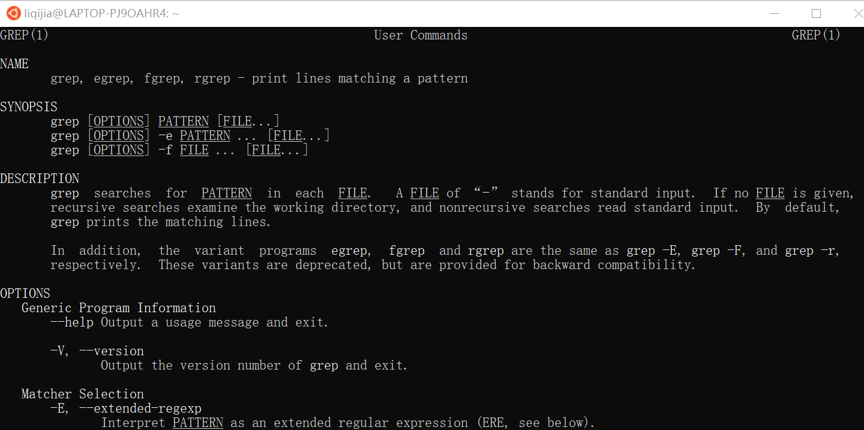

1. Write the command to locate all the *.txt files that contains the word “useful”?

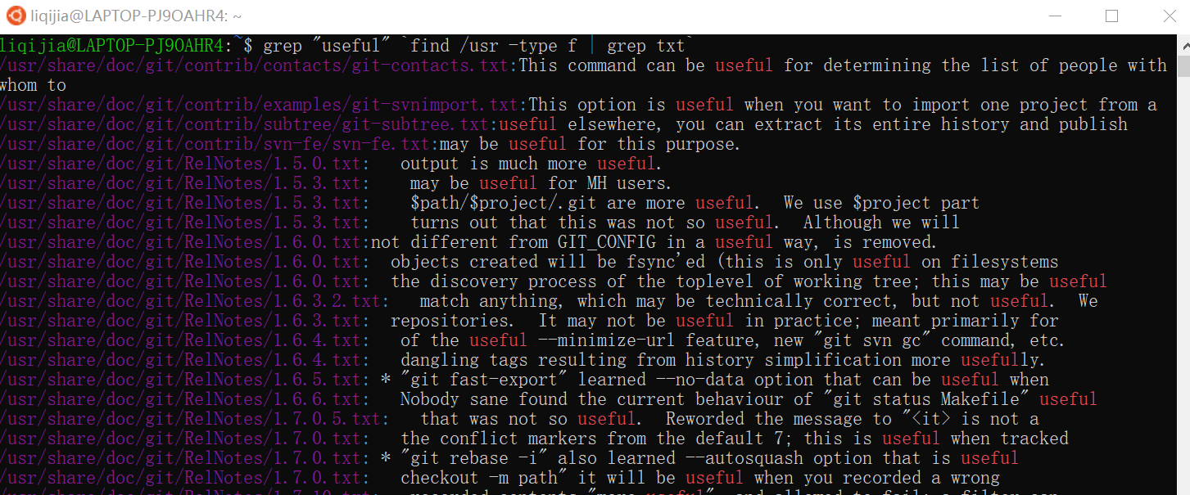

1. Write the command to locate all the *.txt files that contains the word “@{c}”?



1. Write the command to locate all the *.txt files that contains the word “useful”, with “tables” at the end of the sentence?



1. Execute the “history” command and capture the screenshot of its output.





1. Explore and reflect, if/how step 5 can be done in the Window OS/Mac OS environment? (grepWin, our new App may help?)

Use the program editor, like Visual Studio 、Visual Studio Code, input some regular expression to search concrete content.

1. Now, let’s say you work for “Lenovo”, the PC company. In its PC production factories, it has thousands of test data log files (.log filetype). How would you locate the PCs that fail memory test (e.g. fail message: “Fail…DDR5”)? Please demo your command usage to accomplish this task.

**grep "Fail.*DDR5$" `find /usr -type f | grep log`**

**Note, example command sequence is shown below:**

find /usr -type f | egrep -i “\.txt$”

grep "useful" `find /usr -type f | grep txt`

grep "@{c}" `find /usr -type f | grep txt`

grep "useful.*tables$" `find /usr -type f | grep txt`

**Submission:**

Please submit to online. If that fails, email your results to: bangpanliang@gmail.com

The subject of the email should be:

[Your StudentID, Assignment Name]